**FREQUENTLY ASKED QUESTIONS FOR HOSPITALS AND ASCS OAS CAHPS®**

# How do I know if my hospital or ASC is eligible to participate in the OAS CAHPS Survey?

Eligibility requirements for OAS CAHPS are based first on facility-level criteria and second on patient-level criteria. The eligibility criteria for HOPDs and ASCs are listed below.

**HOPD Eligibility.** An HOPD is an outpatient surgery department or specialized department of a hospital that performs outpatient surgeries and procedures. A hospital is eligible to participate in the OAS CAHPS Survey if it has an HOPD or any department that meets **all** of the following criteria:

* + performs procedures that are within the OAS CAHPS-eligible range of CPT-41 Codes for Surgery (i.e., CPT codes between 10004 and 69990 and between 92920 and 93986) or one of the following G-Codes: G0104, G0105, G0121 or G0260;
  + is Medicare-certified, has a CMS Certification Number (CCN), and has in effect an agreement with CMS obtained in accordance with 42 CFR 419 subpart B (General Conditions and Requirements);
  + Bills under Outpatient Prospective Payment System (OPPS) when billing to CMS; and
  + is eligible to participate in the Hospital Outpatient Quality Reporting (Hospital OQR) Program;

**Clarification for Hospital Billing Forms**

The following claim forms are used to bill CMS for institutional charges under OPPS:

* CMS-1450 (formerly known as UB-04)
* 837I electronic form

Note: Billing with CMS-1500 claim form for the Physician Fee Schedule would not be eligible for OAS CAHPS hospital outpatient billing under OPPS.

While facility-level eligibility for OAS CAHPS is based on how HOPDs submit for payment to CMS, OAS CAHPS patient-level eligibility includes all payer types, not only CMS.

Note that all locations that bill under the hospital CCN hospital (both on and off campus) and are eligible based on the criteria above are expected to participate.

Exceptions to participation requirements:

1. Critical access hospitals (CAHs) may choose to participate in OAS CAHPS even though CAHs do not bill under OPPS; participation for CAHs is voluntary.
2. Psychiatric Hospitals (CCN range xx4000- xx4499), Children’s Hospitals (CCN range xx3300- xx3399), and Rehabilitation Hospitals (CCN range xx3025- xx3299) are excluded from OAS CAHPS.
3. Emergency Departments are excluded from OAS CAHPS.
4. Rural Emergency Hospitals (REHs) are excluded from OAS CAHPS.
5. Hospitals located in U.S. Territories are excluded from OAS CAHPS. (There are some exceptions to this exclusion).

**ASC Eligibility.** An ASC is a freestanding medical facility that performs outpatient surgeries and procedures. CMS specifically defines ASCs as distinct entities that operate exclusively for the purposes of furnishing outpatient services to patients. An ASC is eligible to participate in the OAS CAHPS Survey if it meets **all** of the following criteria:

* + performs procedures that are within the OAS CAHPS–eligible range of CPT-42 Codes for Surgery (i.e., CPT codes between 10004 and 69990 and between 92920 and 93986) or one of the following G-codes: G0104, G0105, G0121, or G0260;
  + is Medicare-certified, has a CCN, and has in effect an agreement with CMS obtained in accordance with 42 CFR 416 subpart B (General Conditions and Requirements);
  + bills under ASC Payment System when billing CMS; and
  + is eligible to participate in the Ambulatory Surgical Center Quality Reporting (ASCQR) Program; and

Clarification for ASC Billing Forms

The following claim forms are used to bill CMS for institutional charges under the ASC Payment System:

* CMS-1500
* ASC X12 837P claim form

While facility-level eligibility for OAS CAHPS is based on how ASCs submit for payment to CMS, OAS CAHPS patient-level eligibility includes all payer types, not only CMS.

1. Current Procedural Terminology (CPT) is a registered trademark of the American Medical Association. CPT only copyright 2025 American Medical Association. All rights reserved.
2. CPT only copyright 2025 American Medical Association. All rights reserved.

Some ASCs have more than one location, typically in a geographic region. Each location that bills under the ASC’s CCN and meets the criteria above is eligible to participate.

Exception to participation requirements based on location:

1. ASCs located in U.S. Territories are excluded from OAS CAHPS. (There are some exceptions to this exclusion.)

* For more information, please see any of the following documents:
  + ***Chapter III*** (Survey Participation Requirements) and ***IV*** (Sampling Procedures) in the *OAS CAHPS Survey Protocols and Guidelines Manual* available on the Survey Materials webpage (<https://oascahps.org/Survey-Materials> ).
  + *Getting Started* document available in the Quick Links box on the Home page of OAS CAHPS website (direct link: <https://oascahps.org/OAS_Facility_Outreach.pdf> ).

# My hospital has more than one eligible department. / My ASC has more than one eligible location. Should all eligible departments / ASC locations participate in OAS CAHPS?

Participation in the OAS CAHPS Survey occurs at the CCN-level. Therefore, all eligible hospital departments that bill under the same CCN should participate, and all eligible ASC locations that bill under the same CCN should participate.

# What are the notable differences between Hospital CAHPS (HCAHPS) and OAS CAHPS?

* **Patient Population**: The OAS CAHPS Survey includes only outpatients. The HCAHPS survey includes only inpatients.
* **Survey Administration**: The OAS CAHPS Survey must be administered by CMS-approved survey vendors on the facilities’ behalf. The survey vendor will submit survey data to the OAS CAHPS Data Center on the facilities’ behalf. On HCAHPS, the survey can be administered either by an approved vendor (on behalf of a hospital) or by the hospital.

# When will participation in the OAS CAHPS Survey be linked to reimbursement?

Participation in the OAS CAHPS Survey will be linked to reimbursement beginning with CY 2024 for HOPDs and CY 2025 for ASCs. These plans were detailed in the [CY 2022 Final Rule](https://oascahps.org/OAS_CY2022FinalRule.pdf) and reaffirmed in the [CY 2023 Final Rule](https://oascahps.org/OAS_CY2023FinalRule.pdf), the [CY 2024 Final Rule](https://oascahps.org/OAS_CY2024FinalRule.pdf%20) and the [CY2025 Final Rule](https://oascahps.org/OAS_CY2025FinalRule.pdf). To receive the annual payment update (APU) each year, Medicare-certified HOPDs and ASCs that are not eligible for an exemption must administer the OAS CAHPS Survey on an ongoing (monthly) basis as of January 2024 for HOPDs and January 2025 for ASCs.

# What are the survey participation requirements?

It is the responsibility of Medicare-certified HOPDs and ASCs to participate in the OAS CAHPS Survey. Each payment determination period has an associated reference count period and participation period that corresponds to a calendar year (January to December). The eligibility period (which HOPDs and ASCs should use to determine eligibility for the payment determination period) is the year preceding the data collection period. More information on participation periods is available here: [GETTING STARTED WITH THE OAS CAHPS SURVEY](https://oascahps.org/OAS_Facility_Outreach.pdf)

If an HOPD/ASC served fewer than 60 survey-eligible patients during the eligibility period, the facility can request an exemption. To request an exemption from participating in the OAS CAHPS Survey, an HOPD or ASC must submit a Participation Exemption Request (PER) form for that payment determination period. The PER form is available through the OAS CAHPS website: [Participation Exemption Request (oascahps.org)](https://oascahps.org/For-Facilities/Participation-Exemption-Request) HOPDs and ASCs will need to submit a PER every year for which they wish to seek an exemption from participation.

An additional exemption applies for ASCs. An ASC that qualifies for an exemption from the ASC Quality Reporting (ASCQR) Program because it had fewer than 240 Medicare Fee-for-Service claims (Medicare primary and secondary payer, Medicare Advantage claims are not included) in the year prior to the data collection year for the applicable payment determination would also quality for the exemption from the OAS CAHPS Survey for the same time period. These ASCs will not be required to submit a PER form for the OAS CAHPS Survey for the same time period.

If an HOPD or ASC is eligible to participate, it must follow the participation requirements listed directly below. In addition, the HOPD or ASC must understand the payment determination periods, including key date ranges and deadline dates.

Information about payment determination periods and other participation requirements will be provided in the Final Rule published for the *Hospital Outpatient Prospective Payment and Ambulatory Surgical Center Payment Systems and Quality Reporting Programs* for each calendar year and will also be posted on the OAS CAHPS website*.*

Participating HOPDs or ASCs must:

* Contract with an approved OAS CAHPS Survey vendor to conduct their survey on a monthly basis.
* Authorize the contracted survey vendor to collect and submit OAS CAHPS Survey data to the OAS CAHPS Data Center on the facility’s behalf. HOPDs and ASCs cannot delegate the task of authorizing a vendor to any third party.
* Work with their approved vendor to determine schedule for delivering the patient information file(s) allowing adequate time for vendor sampling and fielding the survey as documented in **Chapter IV** of the *OAS CAHPS Survey Protocols & Guidelines Manual available here:* [Survey Materials](https://oascahps.org/Survey-Materials)
* By the agreed-upon date, compile and deliver to the survey vendor a complete and accurate list of patients (i.e., the patient information file) and information that will enable the vendor to sample patients and administer the survey.
* Use a secure method to transmit patient information files to the survey vendor, ensuring that data are encrypted prior to sending to the vendor.
* Work with their approved vendor to determine a date each month or quarter by which the vendor will submit data to the OAS CAHPS Data Center.
* Review the online Data Submission Report to ensure that their survey vendor has submitted data to the OAS CAHPS Data Center on time and without data problems (allow ample time for this prior to the quarterly data submission deadlines because data cannot be corrected after the deadline has passed).
* For data submitted during voluntary implementation, review OAS CAHPS Survey results via Preview Reports prior to public reporting on the OAS CAHPS website. For data linked to reimbursement, the Preview Reports will be available through the Hospital Quality Reporting (HQR) secure portal.
* Data submitted during voluntary implementation will be publicly reported on the Provider Data Catalog (PDC) website; data linked to reimbursement will be publicly reported on Care Compare on the Medicare.gov website.
* Avoid influencing patients in any way about how to answer the OAS CAHPS Survey. For example, HOPDs and ASCs may not hand out any information to patients about how to answer the survey.

# Are ASCs that are exempt from the ASC Quality Reporting Program also exempt from OAS CAHPS?

Yes. An ASC that qualifies for the exemption from the ASCQR Program because it had fewer than 240 Fee-for-Service Medicare claims (Medicare primary and secondary payer; Medicare Advantage claims are not included) in the year prior to the data collection year for the applicable payment determination, would also qualify for the exemption from the OAS CAHPS Survey for the same time period. These ASCs are not required to submit a Participation Exemption Request (PER) form.

# How do I register my HOPD(s) or ASC(s) on the OAS CAHPS website?

1. 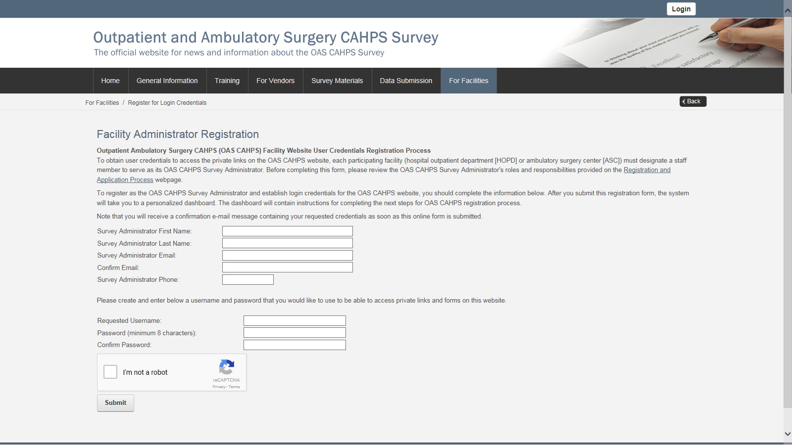Register for login credentials on the OAS CAHPS website by completing the online *Facility Administrator Registration* form. You can access this form by clicking on the **Register for Login Credentials** link under the “For Facilities” menu tab (as shown in the screenshot below) on the OAS CAHPS website [[Home (oascahps.org)](https://oascahps.org/)]. A direct link to the *Facility Administrator Registration* form is provided here: [Register for Login Credentials (oascahps.org)](https://oascahps.org/For-Facilities/Register-for-Login-Credentials)
2. Using the login credentials (username and password) submitted on the registration form mentioned in Step 1 above, log onto the website. The “Login” link can be found in the upper right-hand corner of the Home page (as shown in the screenshot below) or using this link: [User Log In (oascahps.org)](https://oascahps.org/Login?returnurl=%2fFor-Facilities%2fRegister-for-Login-Credentials)

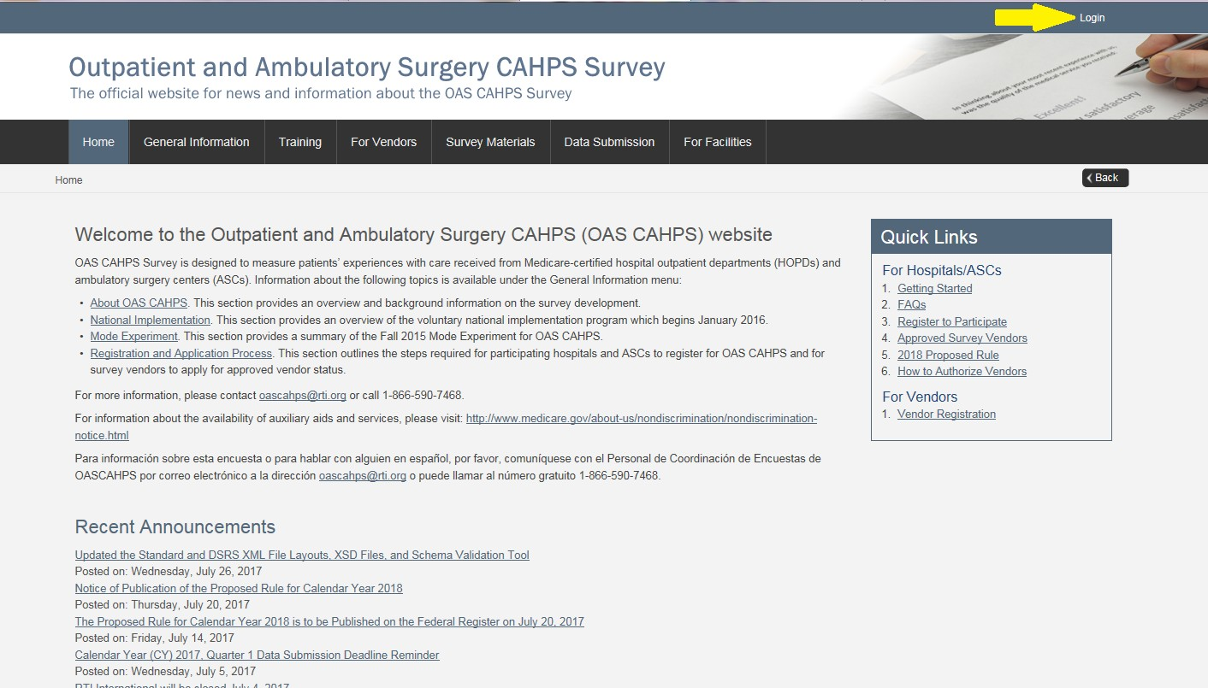

1. Navigate to the *Facility CCN Registration* form available on your customized dashboard (through the “Click here to register your HOPD facility or your ASC facility (by CCN)” link (under the Resource column)). See screenshot below.

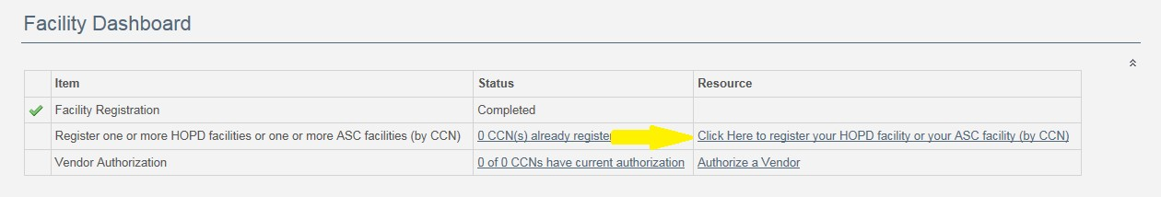

Once you are logged in, you can also access this same form through the **Facility CCN Registration** link under the “For Facilities” menu tab, as shown in the screenshot below.

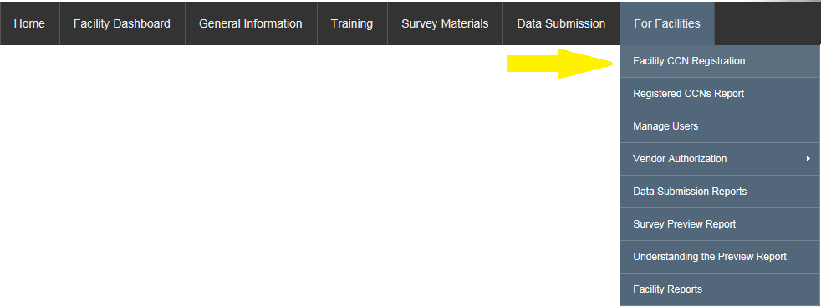

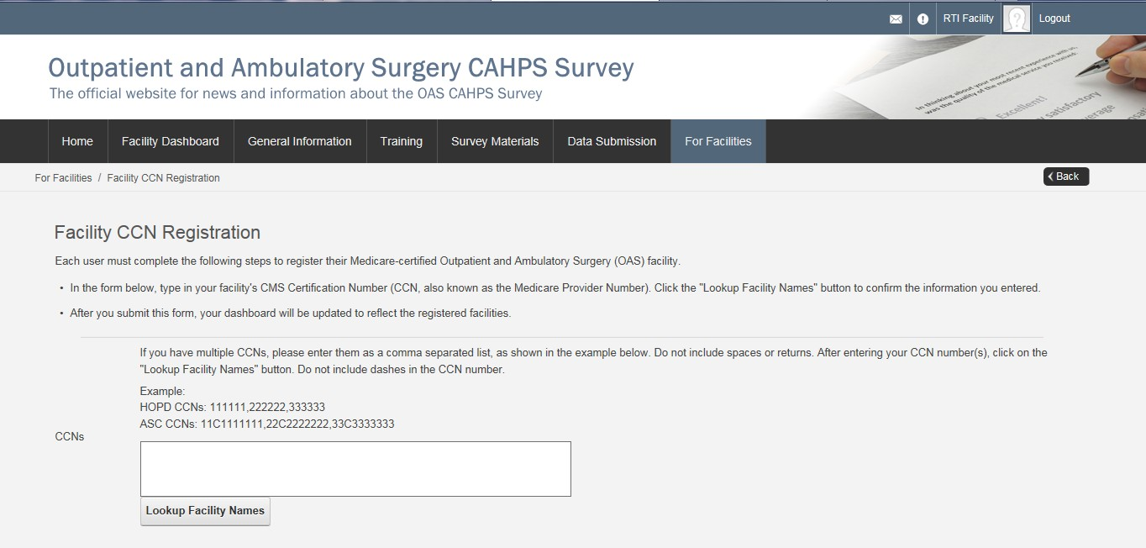

1. On this form, you will enter your facility’s CMS Certification Number (CCN, also known as the Medicare Provider Number). Do not include dashes in the CCN. If you have multiple CCNs, you can enter them as a comma separated list, as shown in the example below. Do not include spaces or returns.

Example:

HOPD CCNs: 111111,222222,333333

ASC CCNs: 11C1111111,22C2222222,33C3333333

1. Then, click the “Lookup Facility Names” button to confirm the information you entered. See example screenshot below. Review the information populated in the Lookup Results table.

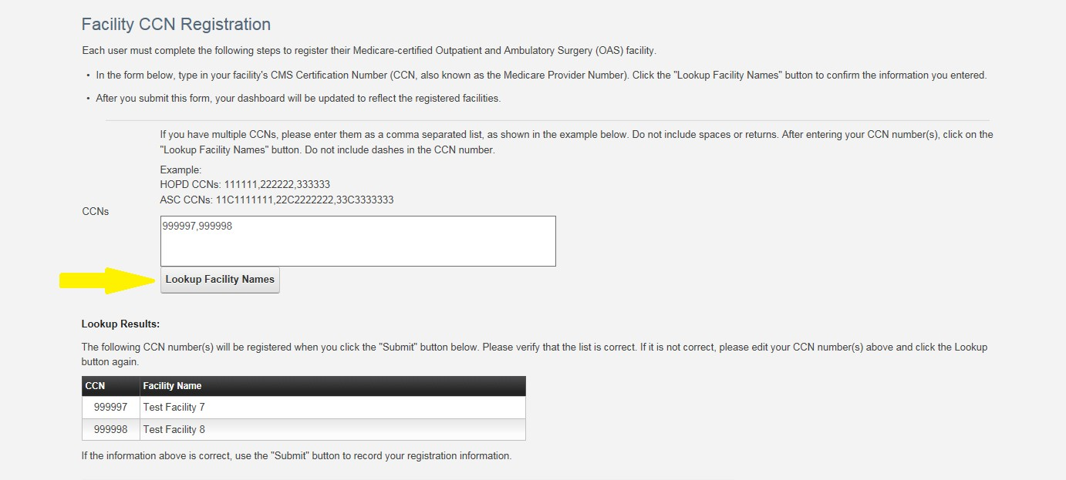

1. To submit the form, the OAS CAHPS Survey Administrator should review and agree to the responsibilities listed at the bottom of the *Facility CCN Registration* form (see below).

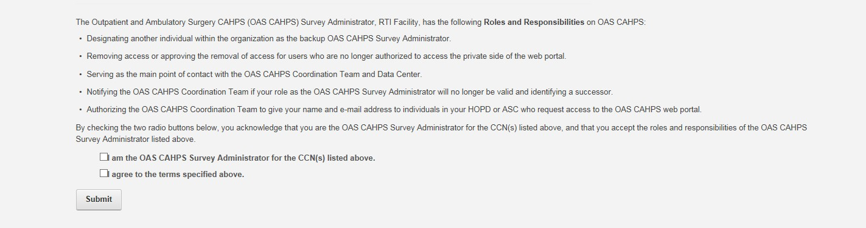

1. After you submit this form, your customized dashboard will be updated to reflect the registered facilities. See example screenshot below.

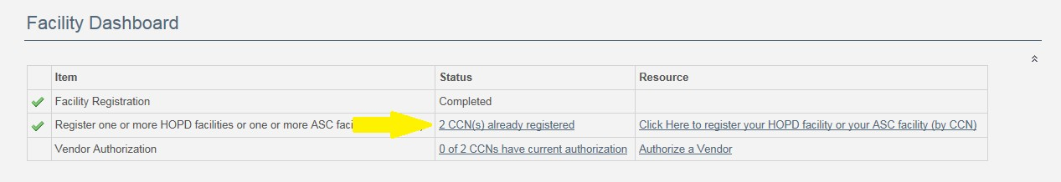

# What is a CCN?

The CMS Certification Number (CCN) is assigned to a facility to verify that a provider has been Medicare certified and for what type of services. The CCN was previously known as the Medicare/Medicaid Provider Number or the Online Survey, Certification and Reporting (OSCAR) Number and is sometimes called the billing number.

The CCN is required to complete the registration process on the OAS CAHPS website. For hospitals, the CCN is a 6-digit number. For ASCs, the CCN is a 10-digit number/character combination with the 3rd character being a “C.”

The CCN is different from the National Provider Identifier (NPI), but the two numbers are linked. The NPI is assigned to covered health care providers and is used for HIPAA standard transactions. You can use the NPI to look up the CCN here: [ASC Lookup Tools (qualityreportingcenter.com)](https://nam04.safelinks.protection.outlook.com/?url=https%3A%2F%2Fwww.qualityreportingcenter.com%2Fen%2Fascqr-program%2Fdata-dashboard%2Fccn%2F&data=05%7C02%7Cekinyara%40rti.org%7C097c1aaa3a354f3504ab08dc7bf838fb%7C2ffc2ede4d4449948082487341fa43fb%7C0%7C0%7C638521553255293150%7CUnknown%7CTWFpbGZsb3d8eyJWIjoiMC4wLjAwMDAiLCJQIjoiV2luMzIiLCJBTiI6Ik1haWwiLCJXVCI6Mn0%3D%7C0%7C%7C%7C&sdata=FKLpIlFRibhQrhZlmTTRwg%2Bg4JgbXN2GE5kdFWVkV3k%3D&reserved=0). Your facility’s billing department can also be a helpful resource in identifying the CCN.

# How do I authorize a vendor for my HOPD(s) or ASC(s) on the OAS CAHPS website?

1. Log in to the private side of the OAS CAHPS website [[Home (oascahps.org)](https://oascahps.org/)] with your username and password. The Login link can be found in the upper right-hand corner of the Home page (as shown in the screenshot below).



1. Go to the “For Facilities” menu and select the “Vendor Authorization” link, and then select “Start an Authorization.”

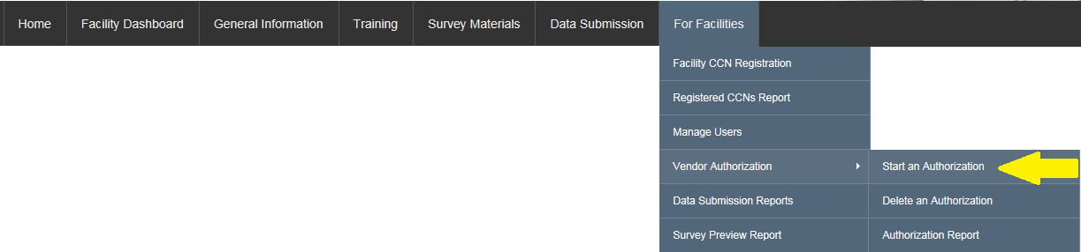

1. On the *Authorize a Vendor* Form, Use the drop-down list under “Select a Vendor” to select your survey vendor.

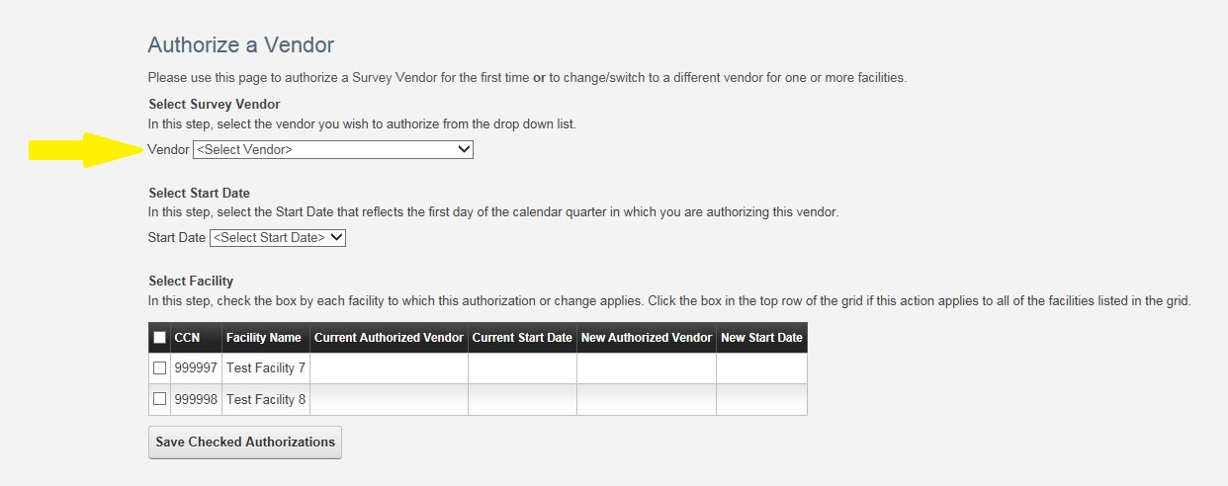

1. Use the drop-down list under “Select Start Date” to select the first day of the calendar quarter for which you are authorizing this vendor to start submitting survey data on your behalf. For example, if a vendor was scheduled to start administering the OAS CAHPS Survey for the January, February or March 2016 sample month, 1/1/2016 should be the selected Start Date.

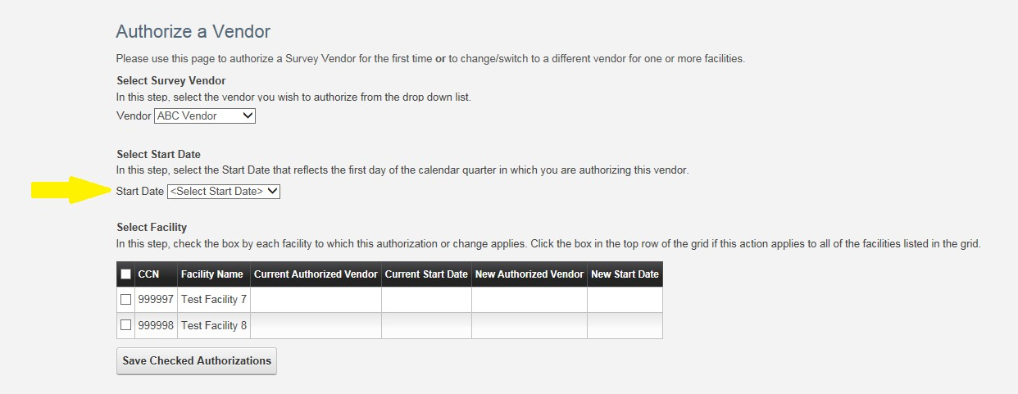

1. Under the “Select Facility” table, check the box next to each facility CCN/name for which the vendor authorization will apply. If you want to apply the vendor authorization to all facilities listed in the box, check the box on the top row of the grid (next to “CCN”).

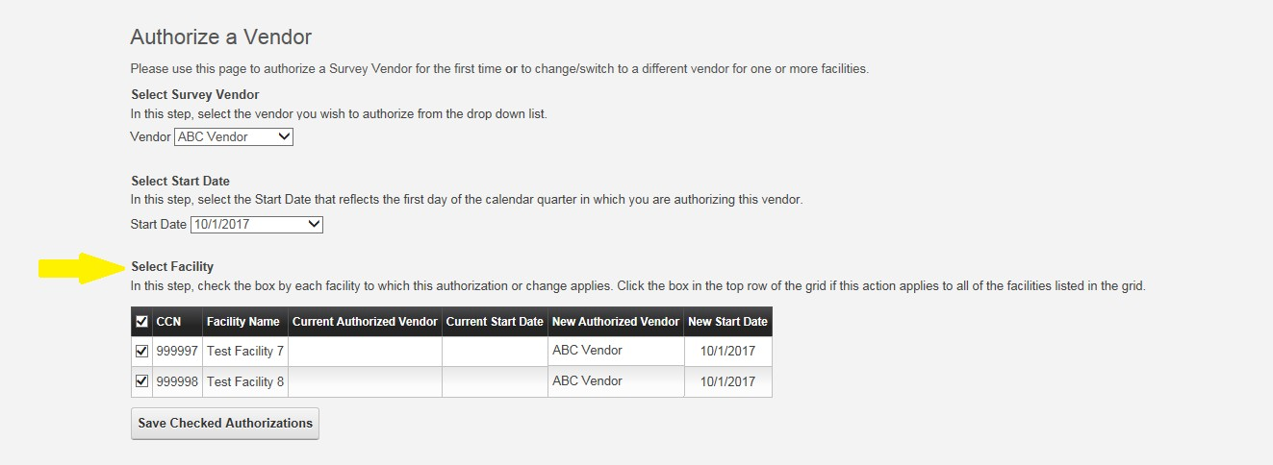

1. Review the information on the form for accuracy. If all is correct, click “Save Checked Authorizations.”

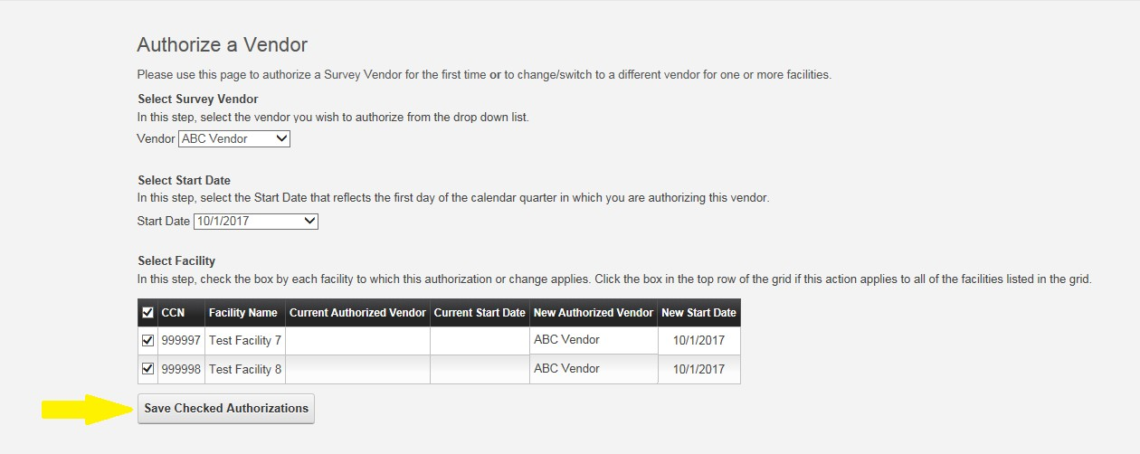

1. After saving, the “Vendor Authorization Report” will display. It shows a table with the vendor authorization status for all the facilities for which you are the Survey Administrator. Any authorizations or changes to authorizations you just saved will be displayed under the column, “Modified” indicated by a green check mark. See example screenshot below.

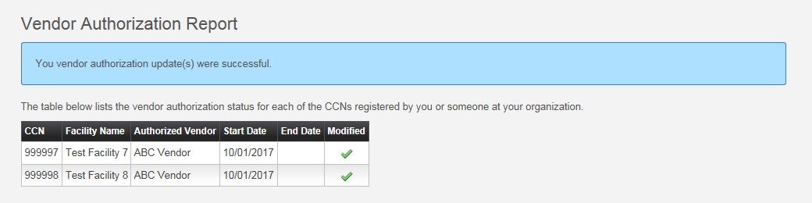

Additional information on vendor authorizations can be found in the document provided here: [The OAS CAHPS Survey Vendor Authorization Form](https://oascahps.org/OAS_Vendor_Auth_Instructions.pdf)

# Where can I find the Participation Exemption Request (PER) form?

* PER form is an online form available on the OAS CAHPS website here: [Participation Exemption Request (oascahps.org)](https://oascahps.org/For-Facilities/Participation-Exemption-Request).
* On the form, HOPDs and ASCs will provide patient counts for a variety of eligibility criteria over a 12-month period (January to December) for a specified year.
* Calculate the number of OAS CAHPS-eligible patients over the 12-month period. If the total is fewer than 60, the PER form can be submitted. If the total is 60 or more, the facility is eligible for participation in the OAS CAHPS Survey and should follow the steps with getting started with the OAS CAHPS Survey linked here: [GETTING STARTED WITH THE OAS CAHPS SURVEY](https://oascahps.org/OAS_Facility_Outreach.pdf)

# We do not serve enough patients to get 300 or 200 completes. What do we do?

The target for the statistical precision of OAS CAHPS Survey results that will be publicly reported is based on a reliability criterion. The reliability target for the OAS CAHPS Survey ratings and most of the composites is 0.8 or higher. For reasons of statistical precision, a target minimum of 300 completed OAS CAHPS Surveys has been set for each HOPD and 200 completed surveys for each ASC over a 12-month reporting period. This is an average of 25 completed surveys per month for HOPDs and 17 completed surveys per month for ASCs.

For small facilities with low patient volumes, the number of survey-eligible patients served may be less than the number required by the sampling rate. In this case, it is acceptable to sample, and then survey, all survey-eligible patients served during that sample month. For small facilities that sample all eligible patients (i.e., conducting a census), the survey measures the true value of the patient population. The survey measures the ***true*** value because ***all*** patients were selected for the survey. Large facilities target 300 (HOPDs) or 200 (ASCs) completed surveys to achieve sufficient statistical precision to reflect their population of patients. Thus, the ratings for large

facilities and the ratings for small facilities both achieve the statistical precision for the OAS CAHPS Survey results based on the reliability criterion targeted.

# We currently administer our own survey to patients. How do we implement both our internal survey and the OAS CAHPS Survey?

A “survey,” for purposes of this project, is defined as a formal, patient experience or satisfaction survey. A formal survey, regardless of the data collection mode employed, is one in which the primary goal is to ask standardized questions of a sample of the patient population. HOPDs and ASCs that are administering other outpatient surveys

**NOTE**: Routine follow-up calls are not considered surveys. Contacting patients to check on their recovery is considered a routine patient contact.

Routine patient contacts should not include OAS CAHPS Survey questions or questions that are similar.

must follow the guidelines below.

Because of the promise of confidentiality stated in the OAS CAHPS Survey letters and email messages, survey vendors are not permitted to share with their HOPD or ASC clients the identities of patients who are sampled for OAS CAHPS.

The following guidelines are strongly recommended if the HOPD or ASC is planning to administer other surveys in conjunction with the OAS CAHPS Survey and will be using the OAS CAHPS Survey vendor to conduct the other survey:

* For each sample month, OAS CAHPS Survey sample should be selected *prior* to the sample(s) for any other survey.
* Patients who were not randomly selected for OAS CAHPS may be included in a sample for any other survey.

Also, the following guidelines are strongly recommended if the HOPD or ASC is utilizing more than one survey vendor or self- administering other surveys in addition to participating in OAS CAHPS:

* HOPDs and ASCs or their other vendor should select a sample of patients for the other survey with the understanding that some patients may be sampled for both the OAS CAHPS Survey and the other survey.
* If another CMS- or other federally sponsored effort is also conducting a survey of patients in the HOPD or ASC that month, the facility must contact the OAS CAHPS Survey Coordination Team to make arrangements for both surveys.
  + **Exception:** HOPDs or ASCs that are participating in the American College of Surgeons’ National Surgical Quality Improvement Program (NSQIP) can administer the OAS

CAHPS Survey in conjunction with the NSQIP post-operative survey to patients such that each survey can be administered independently. In other words, the OAS CAHPS Survey vendor can sample OAS CAHPS patients as they normally would and the NSQIP follow-ups can be administered as required.

NOTE 1: It is up to the facility to evaluate—based on the size, frequency, and purpose of the other survey(s) it conducts—whether to potentially sample its patients more than once or engage the services of their OAS CAHPS Survey vendor to ensure that patients sampled for the OAS CAHPS are not also sampled for their other survey(s).

NOTE 2: Conducting additional surveys with the same patient population as OAS CAHPS may lower OAS CAHPS survey response rates because of respondent survey fatigue.

With regard to questionnaire content of other outpatient surveys:

* They can include questions that ask for more in-depth information about OAS CAHPS issues.
* If the HOPD or ASC can ensure that there is no overlap between the samples, the facility can include any of the OAS CAHPS questions or similar questions.
* If the OAS CAHPS and other survey samples potentially overlap, the facility cannot include any of the OAS CAHPS questions or similar questions.

# Is there an OAS CAHPS training we are required to attend?

OAS CAHPS Survey does not have a training program required for hospitals and ASCs to attend. The annual OAS CAHPS webinar trainings are required for survey vendors. Hospitals and ASCs can voluntarily attend the webinar trainings; however, the webinars focus on the vendors’ responsibilities and include more detail than what a facility would need to know.

# Where can I go for additional information about the OAS CAHPS Survey?

More information about the OAS CAHPS Survey and ambulatory and outpatient surgical care is available at three websites—the OAS CAHPS Survey Website ([Home (oascahps.org)](https://oascahps.org/)), the CMS Website ([Outpatient and Ambulatory Surgery CAHPS (OAS CAHPS) | CMS](https://www.cms.gov/data-research/research/consumer-assessment-healthcare-providers-systems/outpatient-and-ambulatory-surgery-cahps)), and the Medicare Website ([Welcome to Medicare | Medicare](https://www.medicare.gov/)).

1. OAS CAHPS Survey Website [[Home (oascahps.org)](https://oascahps.org/)] This website is maintained by the OAS CAHPS Survey Coordination Team. It provides general information about the OAS

CAHPS Survey, contains the protocols and materials needed for survey implementation, and is one of the main vehicles for communicating information about the survey to HOPDs, ASCs, and survey vendors. The website has both public and secure pages.

1. CMS Website ([Outpatient and Ambulatory Surgery CAHPS (OAS CAHPS) | CMS](https://www.cms.gov/data-research/research/consumer-assessment-healthcare-providers-systems/outpatient-and-ambulatory-surgery-cahps))—This website is maintained by CMS and contains high-level information about the OAS CAHPS Survey.
2. Medicare Website ([Welcome to Medicare | Medicare](https://www.medicare.gov/))—This website is maintained by CMS and contains information on the services Medicare provides. It provides information to the public on various quality measures. Publicly reported OAS CAHPS Survey results for data linked to reimbursement are available on this website, where viewers can obtain comparative information about HOPDs and ASCs by state, ZIP code, and county.

# Who do we contact if we have questions about the OAS CAHPS Survey?

The OAS CAHPS Survey Coordination Team via telephone (1-866-590-7468) or email ([oascahps@rti.org](mailto:oascahps@rti.org)), Monday through Friday between 8:30 AM and 5:00 PM (Eastern Time).